AMERICAN INTERNATIONAL UNIVERSITY BANGLADESH (AIUB)


INTRODUCTION TO DATA SCIENCE
Spring 2022-2023

Interactive Movie Revenue Dashboard using R Shiny

Supervised By: Dr. Akinul Islam Jony

Submitted By
A.S.M. Fazle Rabbi
19-39714-1

Date of Submission: 30th April 2023

Project Overview:
For this project, we have been assigned to scrap data from webpages, perform preprocessing techniques on them, describe them in the light of descriptive statistics and visualize them using R language.
In our project firstly, we chose movie revenue data from the box office. To build an interactive dashboard that displays information about movie rankings based on their worldwide box office revenue, domestic box office revenue, and international box office revenue. The data from 1977 to the present day will be collected through web scraping from "The Numbers" website. After that, we did many comparisons on data like why “Avatar” was the highest ranked movie and analyzed the dataset. Real-world data is frequently incomplete, noisy, and inconsistent, meaning it needs to be cleaned up before it can be put to the intended use. Data pre-processing is a common term for this. Data preprocessing is a data mining technique used to turn raw data into a practical and effective format. The most important tasks involved in data pre-processing are Data Cleaning, Data Integration, Data Transformation, Data Reduction, and Data Discretization. We did data preprocessing where it was needed. In Descriptive analysis, we described our data with the help of descriptive methods. In the descriptive analysis, we describe our data in some manner and present it in a meaningful way so that it can be easily understood. To describe a comparison between different things we did the Mean, Median, Mode, Range, Variance, Quartile & Percentile. Lastly, we did data visualization to see and understand as visualizations can more effectively allow the reader to gather information. Graphics can allow users to deliver insights in a much easier fashion than describing through text and can also have a greater impact. Here we tried to visualize almost every aspect of comparison & relation.
Project Solution Design:
We initially gathered our movie lists and box office income from "The Numbers" website in order to prepare the dataset for data analysis. We then recorded the information in a CSV file. The data pre-processing is then done. Data cleaning is the process of inspecting a raw dataset to find and eliminate errors, duplication, and superfluous data. The table had some missing data, which we removed. Then we tried to manage every item of noisy data that was in the dataset. After performing data cleaning, measures for data integration, data transformation, data reduction, and data discretization were taken to further clean the data set. We concentrated on using descriptive statistics to rationally simplify our enormous volumes of data after completing the data preprocessing. Moreover, to sum up, the dataset's approximate data. In our data collection, we used the following metrics: Mean, Median, Mode, Range, Variance, Standard Deviation, Quartiles, Percentiles, and Interquartile Ranges. We used data visualization to present facts and data graphically after finishing the descriptive statistics.

Data Collection:
For this project, we start to scrap the data from the website. First, we start to scrap the data from "The Numbers" website. In this process, we use a selector gadget to simply select data on a website and it will determine its HTML/CSS tags, ids and classes.
Data Source: The Numbers (https://www.the-numbers.com/movie/budgets/all)
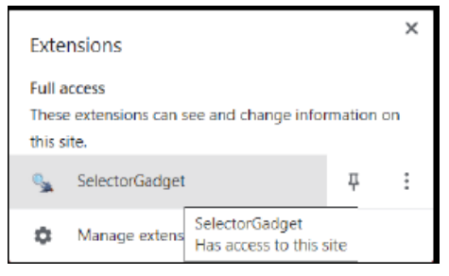
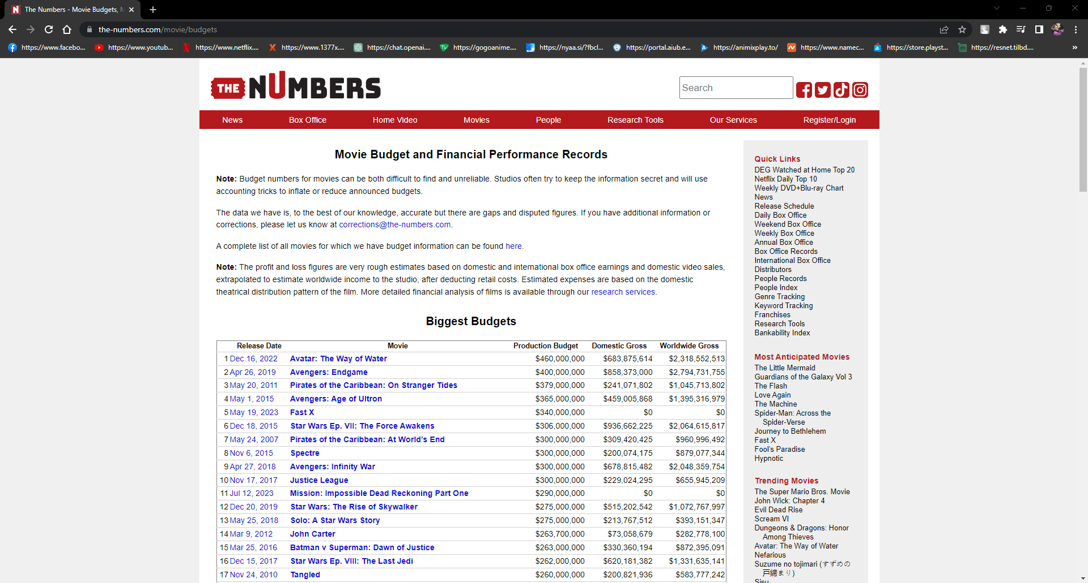
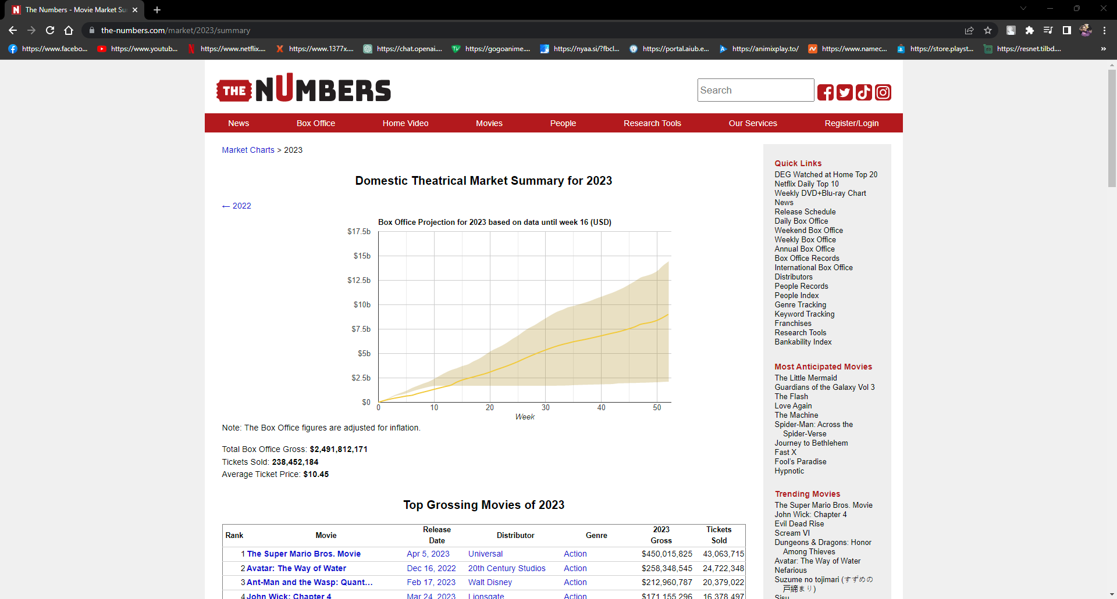
Source code:
#Loading Library
install.packages("rvest","dplyr")
library(rvest)
library(dplyr)

#Creating data frame
Movies = data.frame()

for (page_result in seq(from = 1, to = 2000, by = 100)) {
#URL link
link = paste0("https://www.the-numbers.com/box-office-records/worldwide/all-Movies/cumulative/all-time/",page_result)

#Read the HTML content of the page
page = read_html(link)

#Fetching data from webpage
rank = page %>% html_nodes(".data:nth-child(1)") %>% html_text()
year = page %>% html_nodes(".data a") %>% html_text()
name = page %>% html_nodes("#page_filling_chart b a") %>% html_text()
worldwide_box_office = page %>% html_nodes("td:nth-child(4)") %>% html_text()
domestic_box_office = page %>% html_nodes("td:nth-child(5)") %>% html_text()
international_box_office = page %>% html_nodes("td:nth-child(6)") %>% html_text()

#Adding data into Data Frame
Movies = rbind(Movies, data.frame(rank,name,year,worldwide_box_office,domestic_box_office,
international_box_office, stringsAsFactors = FALSE))

}

#Storing the data frame into csv file for future use
write.csv(Movies, "Movies_data.csv", append = TRUE)
#read.csv("Movies_data.csv")
print(Movies)

Output: First 50 entries
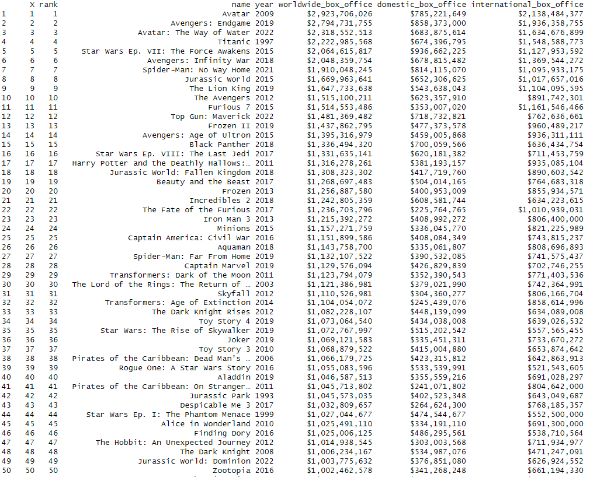

Data Pre-processing:
Now the most important phase of the data analysis starts which is data pre-processing. We are going to use pre-processing techniques on this dataset to prepare a complete dataset for analysis and visualization.
- Data Cleaning:
- Handling Missing Data: To handle missing data we first need to search the data set for any value that is not assigned. To do so we write a code that will show us the row which contains the missing value.
Source code:
#Dropping the X column
Movies_DF <- Movies_DF[c(-1)]

#Handling Missing Data
#Replacing "missing value" with NA
Movies_DF[Movies_DF == ""] <- NA
print(Movies_DF)

#Dropping rows with NA
Movies_DF<- na.omit(Movies_DF)

#Removing $ and , from the dataset
Movies_DF$rank <- gsub("\\$|,", "", as.character(Movies_DF$rank))
Movies_DF$worldwide_box_office <- gsub("\\$|,", "", as.character(Movies_DF$worldwide_box_office))
Movies_DF$domestic_box_office<-gsub("\\$|,", "", as.character(Movies_DF$domestic_box_office))
Movies_DF$international_box_office<-gsub("\\$|,", "", as.character(Movies_DF$international_box_office))

Output:
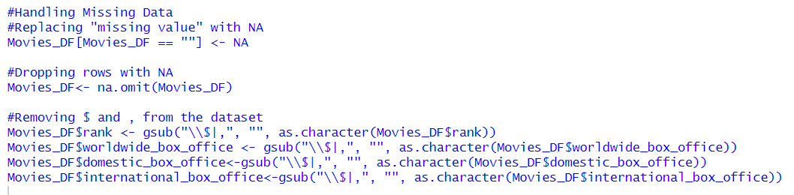
- Smooth Noisy Data: In the dataset, there were many outliers so first we identified them using several methods and removed them.
Source Code:
#Smoothing Noisy Data
#Finding Outliers
max(Movies_DF$worldwide_box_office)
min(Movies_DF$worldwide_box_office)
boxplot(Movies_DF$worldwide_box_office)
worldwide_box_office_sorted <- Movies_DF[order(Movies_DF$worldwide_box_office),"worldwide_box_office"]
worldwide_box_office_sorted

max(Movies_DF$international_box_office)
min(Movies_DF$international_box_office)
boxplot(Movies_DF$international_box_office)
international_box_office_sorted <- Movies_DF[order(Movies_DF$international_box_office),"international_box_office"]
international_box_office_sorted

max(Movies_DF$domestic_box_office)
min(Movies_DF$domestic_box_office)
boxplot(Movies_DF$domestic_box_office)
domestic_box_office_sorted <- Movies_DF[order(Movies_DF$domestic_box_office),"domestic_box_office"]
domestic_box_office_sorted

#Removing Outlier
Movies_DF <- subset(Movies_DF, international_box_office >= 100000)
Movies_DF <- subset(Movies_DF, domestic_box_office >= 100000)

Output:
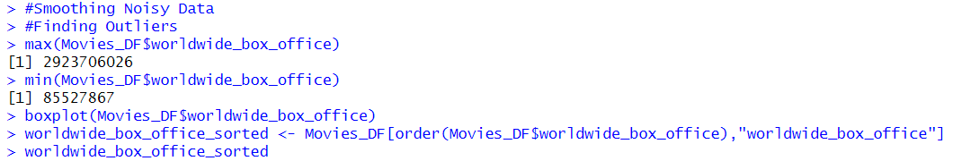
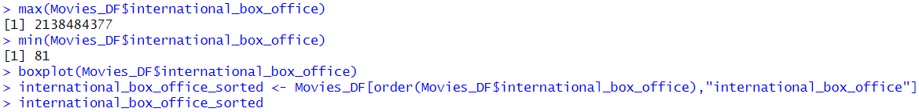
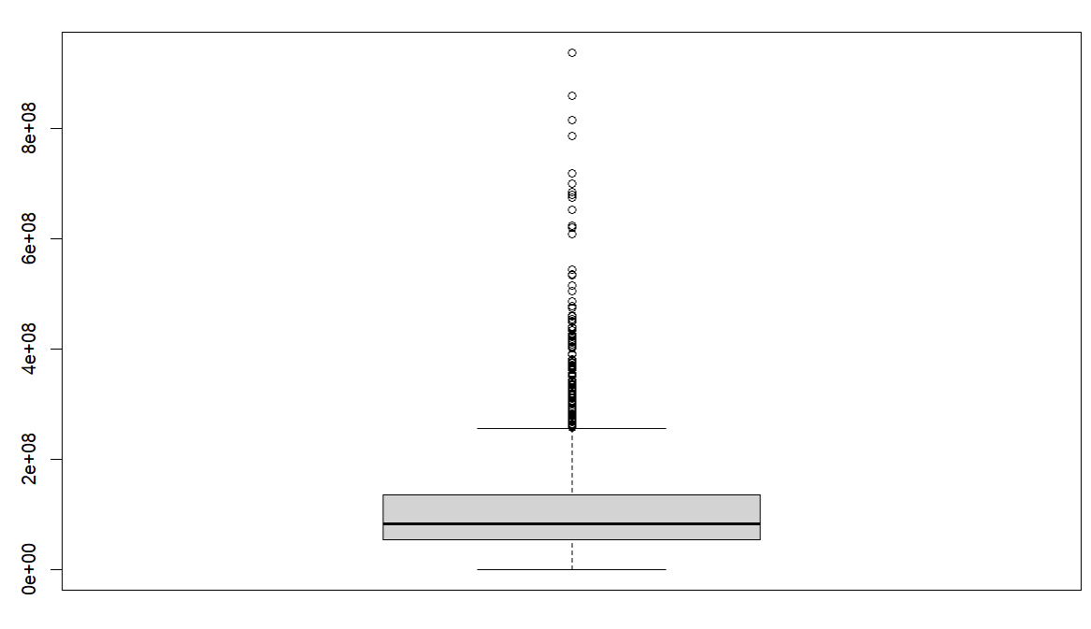
- Data Munging:
The dataset does not require munging because all the data are within the same range.

- Data Integration:
The dataset does not require data integration as all the data are taken from the same dataset.

- Data Transformation:
In this phase, we need to transform some variables for better analysis of the dataset. We need to transform the variables such as rank, year & the box office revenues to numeric.
Source code:
#Data Transformation
#Converting data into numeric
Movies_DF <- transform(Movies_DF,
rank = as.numeric(rank),
year = as.numeric(year),
worldwide_box_office = as.numeric(worldwide_box_office),
domestic_box_office = as.numeric(domestic_box_office),
international_box_office = as.numeric(international_box_office))

Output:
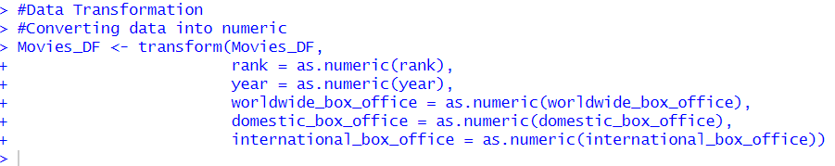

- Data Reduction:
In the data reduction part, we converted the income in millions and added them in new column and changed their name.
Source code:
#Data Reduction
# Create a new column called "worldwide_box_office_million" by dividing "worldwide_box_office" by 1 million
Movies_DF$worldwide_box_office_million <- Movies_DF$worldwide_box_office / 1000000

# Create a new column called "domestic_box_office_million" by dividing "domestic_box_office" by 1 million
Movies_DF$domestic_box_office_million <- Movies_DF$domestic_box_office / 1000000

# Create a new column called "international_box_office_million" by dividing "international_box_office" by 1 million
Movies_DF$international_box_office_million <- Movies_DF$international_box_office / 1000000

#Dropping the column
Movies_DF <- Movies_DF[c(-4,-5,-6)]

#Renaming the column
library(dplyr)
Movies_DF <- rename(Movies_DF, worldwide_box_office = "worldwide_box_office_million",
domestic_box_office= "domestic_box_office_million",
international_box_office = "international_box_office_million")

Output:
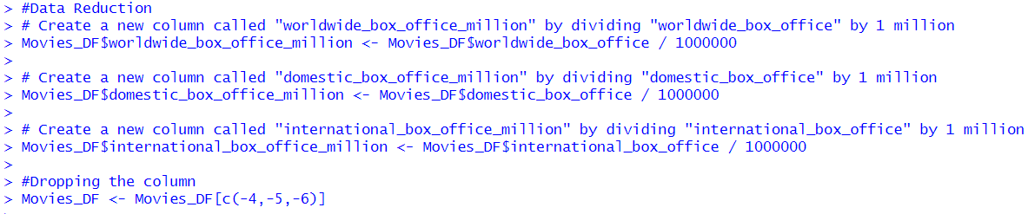
- Data Discretization:
No discretization is needed for this dataset as it is already in better shape. So, we skip this process and move on to descriptive statistics.
Descriptive Statistics:
Now, we are going to compute various descriptive statistics parameters for our dataset. Firstly, let’s try to inspect the central tendency for the various variables of our dataset.
- Mean:
Mean of worldwide box office, domestic box office & international box office.
Source code:
#Mean
mean_worldwide_box_office <- mean(Movies_DF$worldwide_box_office)
paste("Mean of worldwide box office :", mean_worldwide_box_office)

mean_domestic_box_office <- mean(Movies_DF$domestic_box_office)
paste("Mean of domestic box office :", mean_domestic_box_office)

mean_international_box_office <- mean(Movies_DF$international_box_office)
paste("Mean of international box office :", mean_international_box_office)

Output:
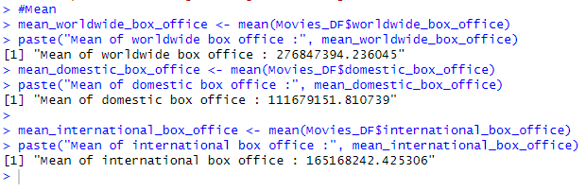
- Median:
Now we calculate the median for the amount of worldwide box office, domestic box office & international box office.
Source code:
#Median
median_worldwide_box_office <- median(Movies_DF$worldwide_box_office)
paste("Median of worldwide box office :", median_worldwide_box_office)

median_domestic_box_office <- median(Movies_DF$domestic_box_office)
paste("Median of domestic box office :", median_domestic_box_office)

median_international_box_office <- median(Movies_DF$international_box_office)
paste("Median of international box office :", median_international_box_office)

Output:
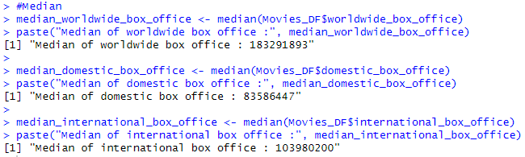
- Mode:
As the mode doesn’t have a built-in function, we first implement the function.
Source code:
#Mode
mode <- function(x){
unique_values <- unique(x)
table <- tabulate(match(x, unique_values))
unique_values[table == max(table)]
}
paste("Mode of year :",mode(Movies_DF$year))

Output:
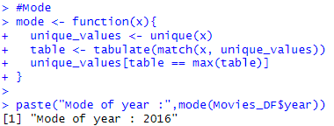
- Range:
Now we calculate the range of variables.
Source code:
#Range
range_worldwide_box_office <- max(Movies_DF$worldwide_box_office) - min(Movies_DF$worldwide_box_office)
paste("Range of worldwide box office :", range_worldwide_box_office)

range_domestic_box_office <- max(Movies_DF$domestic_box_office) - min(Movies_DF$domestic_box_office)
paste("Range of domestic box office :", range_domestic_box_office)

range_international_box_office <- max(Movies_DF$international_box_office) - min(Movies_DF$international_box_office)
paste("Range of international box office :", range_international_box_office)

Output:
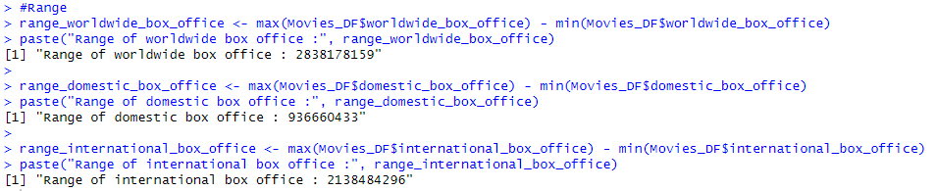
- Variance:
Source code:
#variance
variance_worldwide_box_office <- var(Movies_DF$worldwide_box_office)
paste("Variance of worldwide box office :", variance_worldwide_box_office)

variance_domestic_box_office <- var(Movies_DF$domestic_box_office)
paste("Variance of domestic box office :", variance_domestic_box_office)

variance_international_box_office <- var(Movies_DF$international_box_office)
paste("Variance of international box office :", variance_international_box_office)

Output:
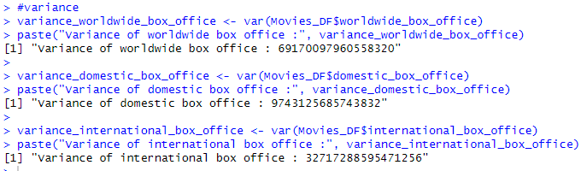
- Standard Deviation:
Source code:
#Standard Deviation
standard_deviation_worldwide_box_office <- sd(Movies_DF$worldwide_box_office)
paste("Standard Deviation of worldwide box office :", standard_deviation_worldwide_box_office)

standard_deviation_domestic_box_office <- sd(Movies_DF$domestic_box_office)
paste("Standard Deviation of domestic box office :", standard_deviation_domestic_box_office)

standard_deviation_international_box_office <-sd(Movies_DF$international_box_office)
paste("Standard Deviation of international box office :", standard_deviation_international_box_office)

Output:
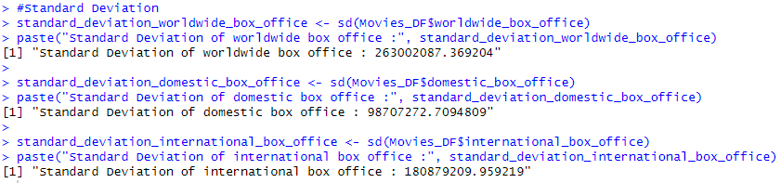

- Quantile:
Source code:
#Quantile
quantile(Movies_DF$worldwide_box_office)

quantile(Movies_DF$domestic_box_office)

quantile(Movies_DF$international_box_office)

Output:
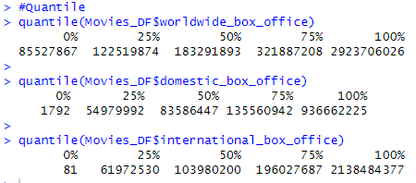

- Percentiles:
Source code:
#Percentiles
percentiles_worldwide_box_office <- IQR(Movies_DF$worldwide_box_office)
paste("Percentiles of worldwide box office :", percentiles_worldwide_box_office)
percentiles_domestic_box_office <- IQR(Movies_DF$domestic_box_office)
paste("Percentiles of domestic box office :", percentiles_domestic_box_office)

percentiles_international_box_office <- IQR(Movies_DF$international_box_office)
paste("Percentiles of international box office :", percentiles_international_box_office)

Output:
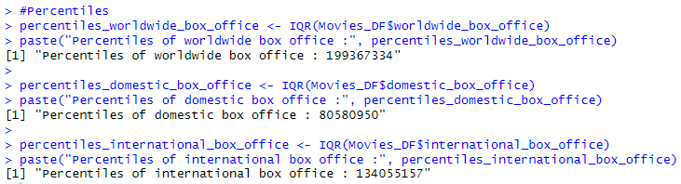
Data Visualization:
Now we plot point, pie chart, bar chart & density to represent the data.
Source code:
#Data Visualization
#Geom-point
library(ggplot2)
ggplot(data = Movies_DF, mapping = aes(x = year, y = worldwide_box_office)) + geom_point(color='blue', alpha = .7, size = 1.5)+geom_smooth(color="black",method =lm, se= FALSE)

#piechart
library(ggpie)
Movies_DF %>% ggpie(group_key = "year",count_type = "full", label_type = "circle",
label_info = "ratio", label_pos = "out",label_size = 3,nudge_x = 20)

#Geom-bar
ggplot(Movies_DF,aes(x=year, fill=international_box_office))+
geom_bar()+
labs(title = "Contribution Of International Box Office", x ="Year", y="International Box Office")

Movies_DF %>% ggplot(aes(x= year,y= worldwide_box_office, fill=year))+
geom_bar(stat = "identity")+
labs(x="Year",y="Worldwide_box_office", title = "Year By Worldwide Box Office")

#Density
Movies_DF%>% ggplot(aes(x= year, y= domestic_box_office))+
geom_density(stat = "identity", fill="red", bw= 1)+
labs(x="Year",y="Domestic Box Office", title = "Year Vs Domestic Box Office")

#New Data Frame

# Create a new dataframe from a subset of the old dataframe "Movies_DF"
New_Movies_DF <- Movies_DF[, c("name", "year", "domestic_box_office","international_box_office",
"worldwide_box_office")]

# Change the column names of the new dataframe
colnames(New_Movies_DF) <- c("Name", "Year", "Domestic Box Office ($ Million)", "International Box Office ($ Million)",
"Worldwide Box Office ($ Million)")

Output:
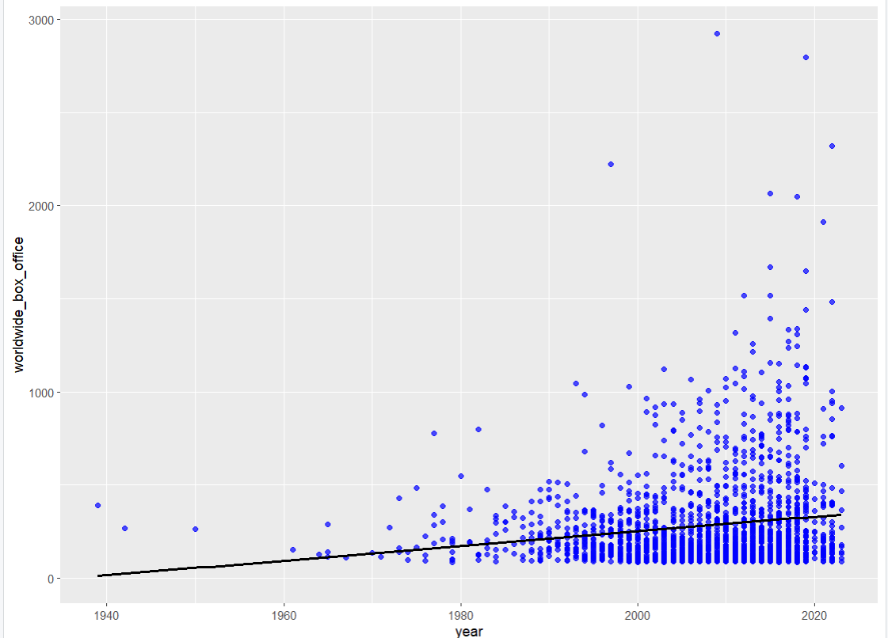

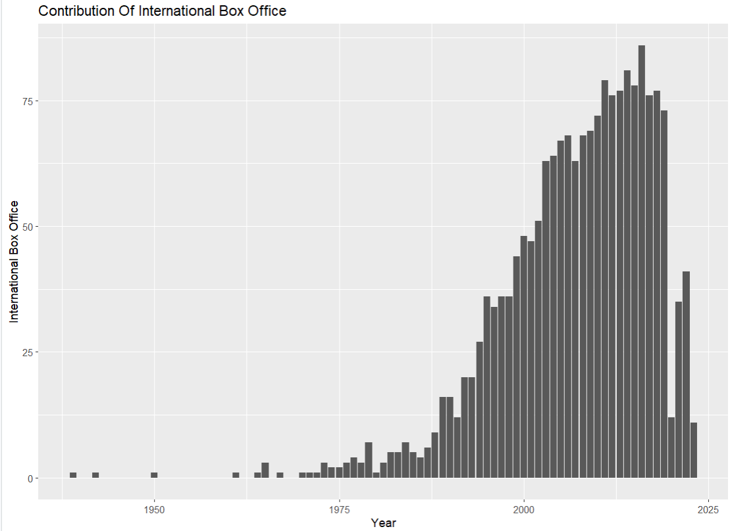

Shiny Dashboard Implementation:
For the shiny dashboard implementation, we tried to create a reactive app based on our topic. We tried to show a reactive line plot, scatter plot and a bar plot.
Source code:
#Interactive dashboard
library(shiny)
library (DT)
library(ggplot2)

ui = fluidPage(
titlePanel("Box Office Insights: Analyzing Worldwide Movie Revenue"),
tabsetPanel(
tabPanel("Table", div(dataTableOutput("table"), style="margin-top: 20px")),
tabPanel("Statistics",
verbatimTextOutput("stats1"),
verbatimTextOutput("stats2"),
verbatimTextOutput("stats3"),
verbatimTextOutput("stats4")),

tabPanel("Graph",
fluidRow(
column(3,
wellPanel(
selectInput("x_var", "X Variable",
choices = c("domestic_box_office", "international_box_office","worldwide_box_office","year"),
selected = "year"
)
)
),
column(3,
wellPanel(
selectInput("y_var", "Y Variable",
choices = c("domestic_box_office", "international_box_office","worldwide_box_office","year"),
selected = "domestic_box_office"
)
)
),
column(3,
wellPanel(
selectInput("plot_type", "Select Plot Type",
choices = c("Point", "Bar", "Density"),
selected = "Point"
)
)
)
),
plotOutput("plot"))
)
)

server = function(input, output) {
output$table <- renderDataTable({
datatable(New_Movies_DF,
options = list(pageLength = 15,
lengthMenu = c(5, 10, 15, 20),
searching = TRUE))
})

output$stats1 <- renderPrint({
# Calculate the variance, standard deviation and range
variance_domestic <- var(Movies_DF$domestic_box_office)
sd_domestic <- sd(Movies_DF$domestic_box_office)
range_domestic <- range(Movies_DF$domestic_box_office)

variance_international <- var(Movies_DF$international_box_offic)
sd_international <- sd(Movies_DF$international_box_offic)
range_international <- range(Movies_DF$international_box_office)

variance_worldwide <- var(Movies_DF$worldwide_box_office)
sd_worldwide <- sd(Movies_DF$worldwide_box_office)
range_worldwide <- range(Movies_DF$worldwide_box_office)

# Print the results
cat("Mode of year :",mode(Movies_DF$year), "\n\n")
cat("Variance Domestic Box Office ($ Million): ", variance_domestic, "\n")
cat("Standard Deviation Domestic Box Office ($ Million): ", sd_domestic, "\n")
cat("Range: ", range_domestic[1], " - ", range_domestic[2], "\n")
cat("\n")
cat("Variance International Box Office ($ Million): ", variance_international, "\n")
cat("Standard Deviation International Box Office ($ Million): ", sd_international, "\n")
cat("Range: ", range_international[1], " - ", range_international[2], "\n")
cat("\n")
cat("Variance Worldwide Box Office ($ Million): ", variance_worldwide, "\n")
cat("Standard Deviation Worldwide Box Office ($ Million): ", sd_worldwide, "\n")
cat("Range: ", range_worldwide[1], " - ", range_worldwide[2], "\n")

})

output$stats2 <- renderPrint({
cat("Summary of Domestic Box Office ($ Million)", "\n\n")
summary(Movies_DF$domestic_box_office)
})

output$stats3 <- renderPrint({
cat("Summary of International Box Office ($ Million)", "\n\n")
summary(Movies_DF$international_box_office)
})

output$stats4 <- renderPrint({
cat("Summary of Worldwide Box Office ($ Million)", "\n\n")
summary(Movies_DF$worldwide_box_office)
})

output$plot <- renderPlot({

# get user inputs
x_col <- input$x_var
y_col <- input$y_var
plot_type <- input$plot_type

# check if the input columns exist in the data frame
if(!all(c(x_col, y_col) %in% colnames(Movies_DF))) {
return(NULL)
}

# create plot based on selected plot type
if(plot_type == "Point") {
ggplot(Movies_DF, aes_string(x = x_col, y = y_col)) +
geom_point() +
labs(x = x_col, y = y_col)
} else if (plot_type == "Bar") {
ggplot(Movies_DF, aes_string(x = x_col, y = y_col, fill = factor(Movies_DF$year))) +
geom_bar(stat = "identity") +
labs(x = x_col, y = y_col, fill = "Year")
} else if (plot_type == "Density") {
ggplot(Movies_DF, aes_string(x = y_col)) +
geom_density() +
labs(x = y_col, y = "Density")
}
})
}

shinyApp(ui, server)

Output:
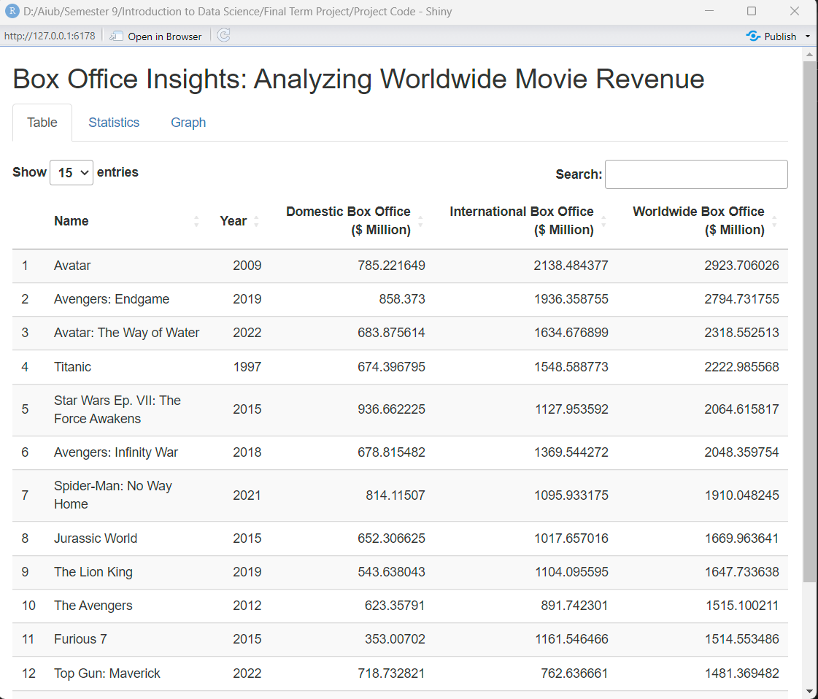

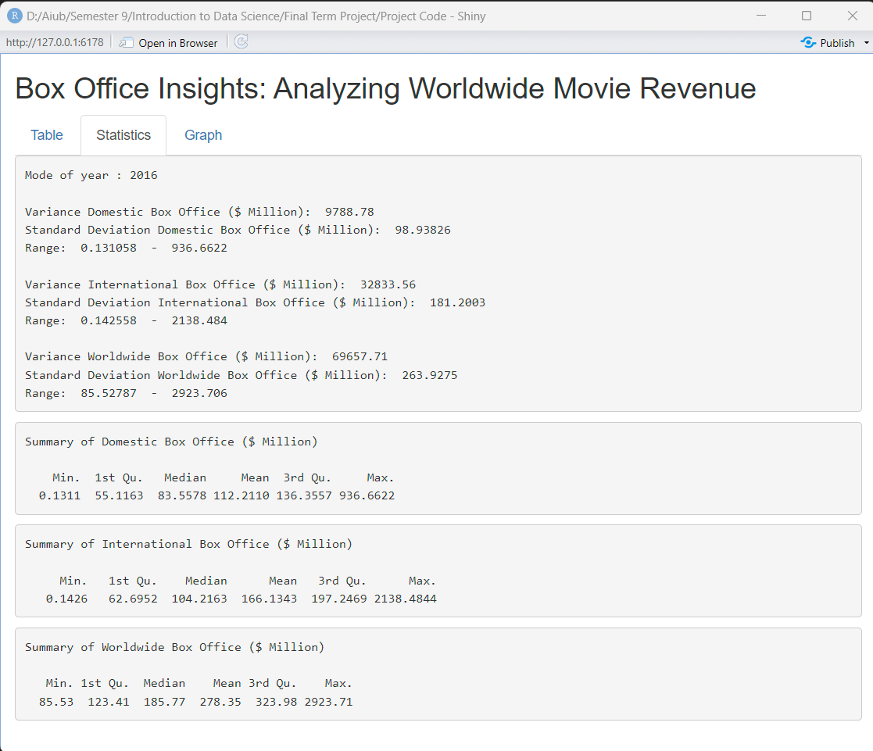
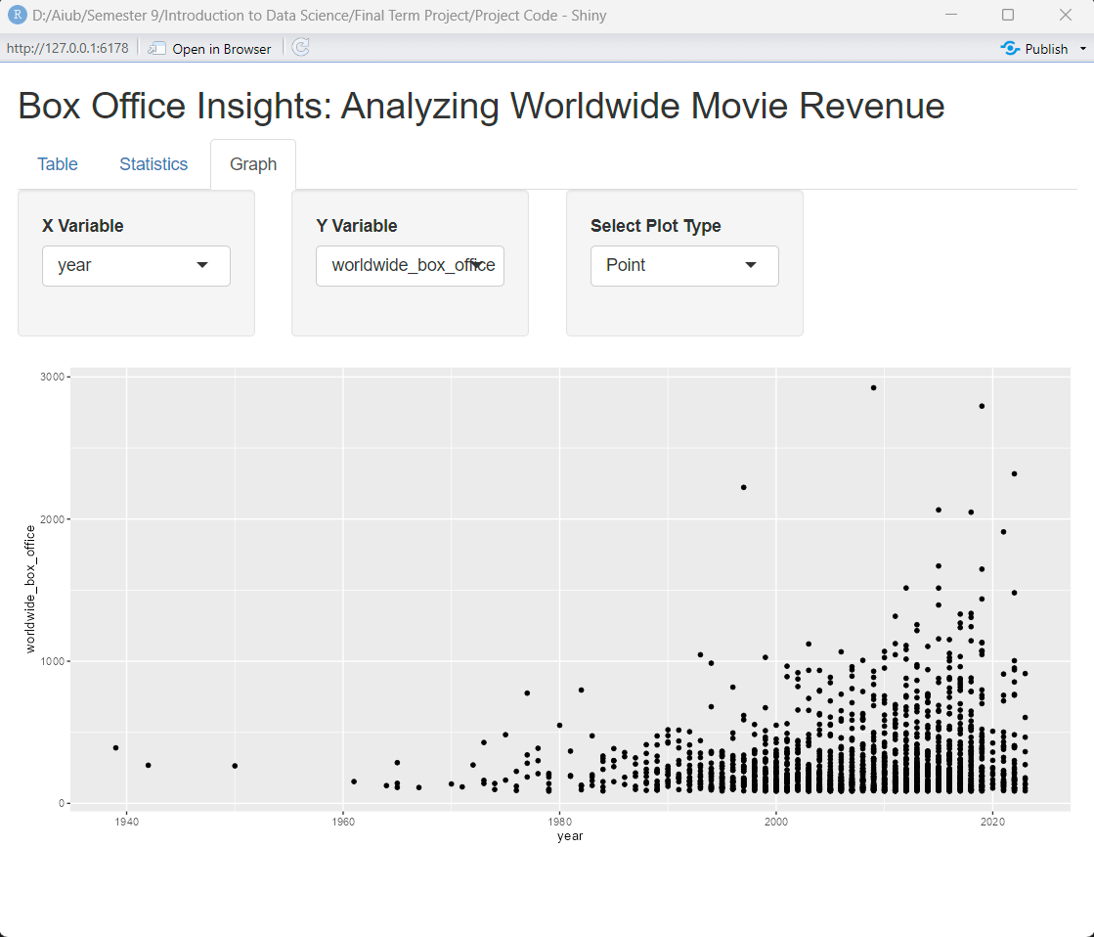
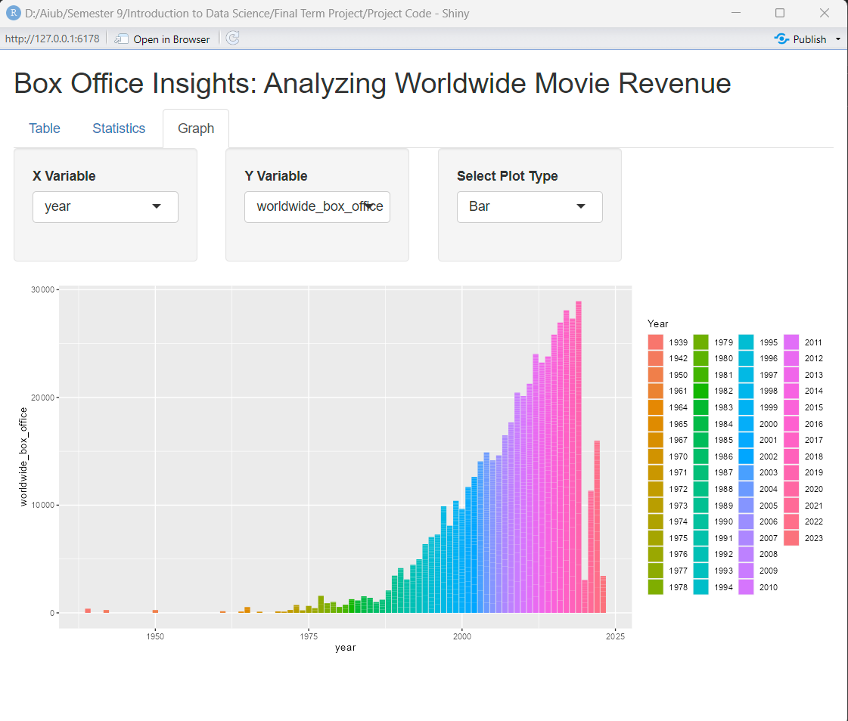
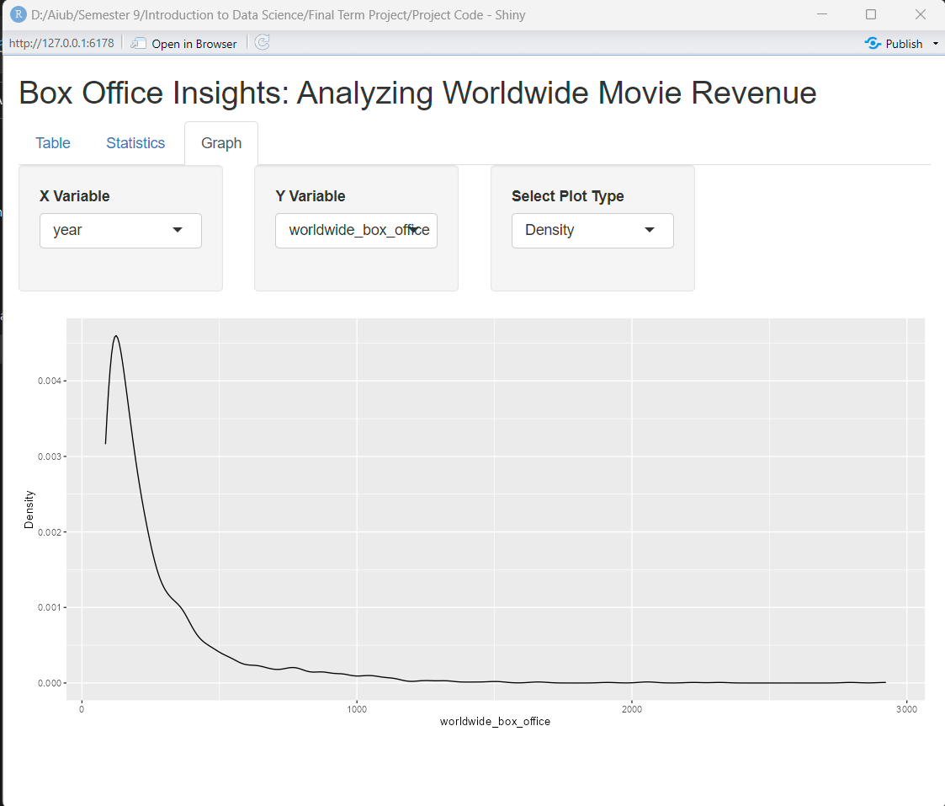
Discussion:
The project aimed to build an interactive dashboard using Shiny framework based on web scraping data from "The Numbers" website. The dashboard allows users to filter the movie rankings data by revenue type & year to get a more personalized view of the movie rankings.
Web scraping was used to collect the data from "The Numbers" website. The data collected included movie titles, release year, worldwide box office revenue, domestic box office revenue, and international box office revenue. Rvest package in R was used to scrap the data.
Shiny framework was used to build the interactive dashboard. The dashboard consists of three tabs, each displaying the table, statistical summary and graph. The dashboard was interactive for user to check and search from the table as well as generate various graphs.
The project has demonstrated the usefulness and potential of web scraping and interactive dashboard development using Shiny framework. The dashboard provides a valuable tool for anyone interested in analyzing and exploring movie rankings data. The interactive components of the dashboard make it user-friendly and responsive.

Conclusion:
In conclusion, the project has successfully developed an interactive dashboard using Shiny framework that displays information about movie rankings based on their worldwide box office revenue, domestic box office revenue, and international box office revenue. The project demonstrated the usefulness of web scraping in collecting data and the tidy verse package in R for data processing.
The interactive dashboard provides users with the ability to filter and explore the data in a personalized way. The dashboard is user-friendly and responsive, making it easy to use and navigate. The project has also demonstrated the potential of deploying the dashboard on a web server to make it accessible to the public.
Overall, this project has provided valuable insights into web scraping and interactive dashboard development using Shiny framework. It provides a valuable tool for anyone interested in analyzing and exploring movie rankings data. The project has shown that with the right tools and techniques, it is possible to collect and process large amounts of data and create interactive dashboards that are user-friendly and responsive.

